# Experiment No: 10

**Aim:**

1.write a shell script to find the greatest of two numbers

2.Write a shell script to find greatest of three numbers.

# CO2:

Perform System Administration tasks.

# Procedure:

1.write a shell script to find the greatest of two numbers

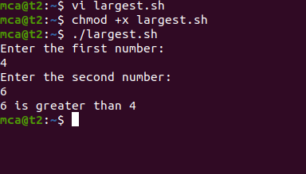

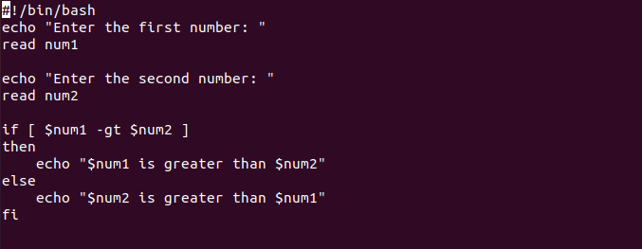

2.Write a shell script to find greatest of three numbers.

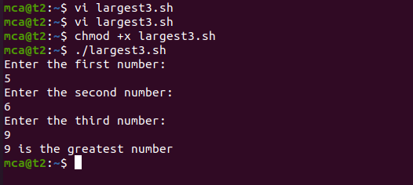

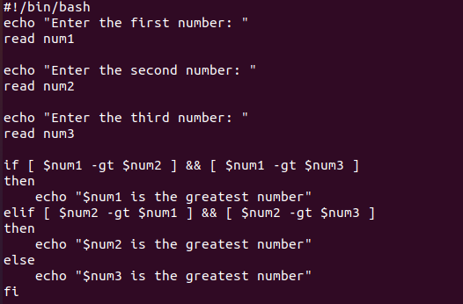

# Result:

The program was executed and the result was successfully obtained. Thus CO2 was obtained.